JTable becomes uglier with AUTO_RESIZE_OFF
Here is the screenshot of JTable with AUTO_RESIZE_OFF
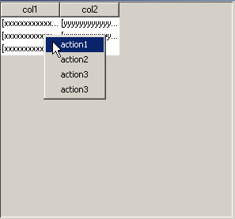
now we start the make-up.
There is lot of gray background (it is JViewPort) which screws up the JTable look. Another interesting thing is when you right click on this gray area popup won't appear, because we attached mouse listener to JTable not to JViewPort.
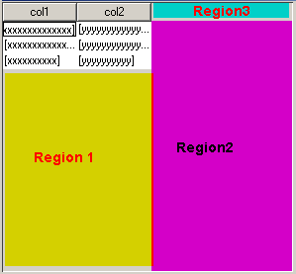
I divided the gray background into 3 regions. We will attack each region one by one.
Region1:
we will make JTable occupy this region by overriding following method:
public boolean getScrollableTracksViewportHeight() {
return getPreferredSize().height < getParent().getHeight();
}
now you will get popup when you right click in region1.
Region2:
we can't override getScrollableTracksViewPortWidth() same as above. If you by mistake do so, JTable behaves like AUTO_RESIZE_ALL_COLUMNS.
we just make the viewport background same as table background by overriding configureEnclosingScrollPane()
protected void configureEnclosingScrollPane() {
.....
viewport.setBackground(getBackground());
.....
}
But there is still one problem. we don't get popup menu on right click in this region. To attack this we use a mouse listener.
MouseListener viewPortMouseListener = new MouseAdapter(){
public void mouseClicked(MouseEvent e){
repostEvent(e);
}
public void mousePressed(MouseEvent e){
repostEvent(e);
}
public void mouseReleased(MouseEvent e){
repostEvent(e);
}
public void mouseEntered(MouseEvent e){
repostEvent(e);
}
public void mouseExited(MouseEvent e){
repostEvent(e);
}
private void repostEvent(MouseEvent e) {
MouseEvent e2 = SwingUtilities.convertMouseEvent(e.getComponent(), e, MyTable.this);
dispatchEvent(e2);
}
};
this mouse listener listens for mouse events from JViewPort and reposts those events to JTable.
When should we add this mouse listener??
Answer is override configureEnclosingScrollPane() add this listener to viewport.
Don't forget to remove this listener in unconfigureEnclosingScrollPane()
Region3:
We replace JScrollPane's column view with a panel containing TableHeader + a dummy label which looks like TableColumn
private JPanel headerPanel = new JPanel(new BorderLayout());
private JLabel dummyColumn = new JLabel(){
public Border getBorder(){
return UIManager.getBorder("TableHeader.cellBorder");
}
};
override configureEnclosingScrollPane() and do the following:
headerPanel.removeAll();
headerPanel.add(getTableHeader(), BorderLayout.WEST);
headerPanel.add(dummyColumn, BorderLayout.CENTER);
scrollPane.setColumnHeaderView(headerPanel);
now our JTable is ready for demo.
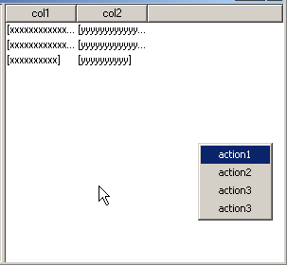
it looks now same as the file table in windows explorer :)

